|  |
| --- |
| Name- Laura Adam |

CTS-120-841-Lab Module 8

1. Save the lab as a PDF, naming it:
   * **FirstName_Lastname-Module#-Lab.pdf**

The objectives of this lab assignment include

* Create hard disk partitions using **fdisk** utility
* Mount partitions onto the directory tree with the **mount** command
* Update the filesystem table (**/etc/fstab**)
* Modify user permissions

## Step 1. Create a new HD to extend the VM you already have

1. Power off the virtual machine.
2. Edit the virtual machine settings and extend the virtual disk size.
   1. Go to vm settings and click on the Hard Disk(SCSI)
   2. Click on Expand
   3. Change the **Maximum disk size (GB)** to **35** (or add 5 to whatever you have), and click **Expand**
   4. Click OK
   5. Click OK to close the VM settings
3. Power on the virtual machine.
4. Identify the device name, which is by default /dev/sda, and confirm the new size by running the command:  
     
    sudo fdisk –l
5. It should be ~37.6 GB

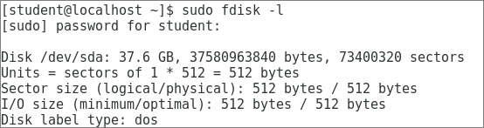

## Step 2. Create a New Partition and Modify the Partition Types

1. Run the command:  
    sudo fdisk /dev/sda

|  |
| --- |
| 1. Press p to print the partition table to identify the number of partitions.   By default, there are two: sda1 and sda2. Show me the partitions. |
| /dev/sda1 * 2048 2099199 1048576 83 Linux  /dev/sda2 2099200 62914559 30407680 8e Linux LVM |

1. Press **n** to create a new primary partition.
2. Press **p** for primary.
3. Press **3** (that should be default) for the partition number
4. Press Enter two times.(default First and last sectors)
5. Press **t** to change the system's partition ID.
6. Keep the partition ID **3**
7. Press **L** to list all the codes
   1. Type whatever Hex code creates the partition as Linux LVM.
   2. If it does not show the following: hit q to exit without saving and start Step 2 again

Changed type of partition 'Linux' to 'Linux LVM'

1. Press **w** to write the changes to the partition table.
2. Reboot the system

## Step 3. View the new partition

1. Log into the linux machine and open up a terminal window.
2. Run the **fdisk** utility on the primary hard drive:

**fdisk /dev/sda**

View the partition table with the **p** command.

|  |
| --- |
| 1. What is different now? – show me the output |
| There are three partitions now  Device Boot Start End Blocks Id System  /dev/sda1 * 2048 2099199 1048576 83 Linux  /dev/sda2 2099200 62914559 30407680 8e Linux LVM  /dev/sda3 62914560 73400319 5242880 8e Linux LVM |

|  |
| --- |
| 1. From the command output, which partition is identified as the boot partition? 2. How can you tell? |
| Sda 1 – because there is an asterisk in the boot column *q  su |

## Step 4. Format the New Partition

1. Type **q** to exit the **fdisk** tool
2. Type **su** to switch to root user.

The rest of this lab should be done as su

1. Create a xfs filesystem by using the mkfs.xfs command, with the name of the partition you created like this:

**sudo mkfs.xfs -f /dev/sda3**

## Step 5. Mounting the xfs filesystem

1. To mount the newly created partition you will have to first create a directory to be a mount point, in our example we will use /newfs.

**sudo mkdir /newfs**

1. Next mount the xfs partition using the mount command

**sudo mount /dev/sda3 /newfs**

1. Then use the mount command to check if the partition was correctly mounted.

**sudo mount |grep /dev/sda3**

|  |
| --- |
| 1. Is the new partition mounted? -   How can you tell?  Show me the output. |
| Because the new partition name (/dev/sda3)ls is highlighted in red  [root@localhost student]# sudo mount |grep /dev/sda3  /dev/sda3 on /newfs type xfs (rw,relatime,seclabel,attr2,inode64,noquota) |

The configuration file /etc/fstab contains the necessary information to automate the process of mounting partitions automatically at boot.

1. Using what you learned in vi, add the following line to **/etc/fstab** to specify how and where we want to mount the new partition;.

/dev/sda3 /newfs xfs defaults 0 0

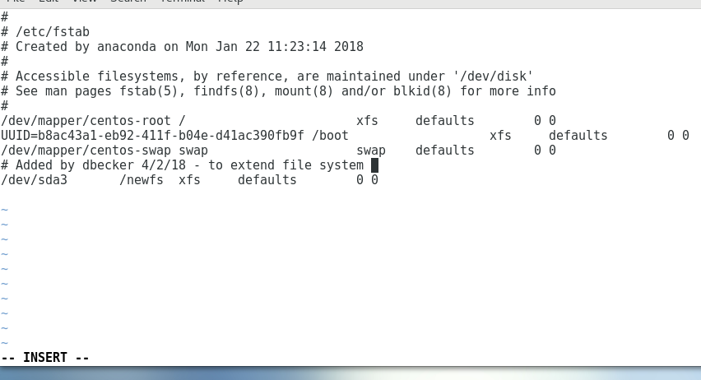

|  |
| --- |
| 6. Show me a screen print of the file before you save it in **vi** like above: |
| /dev/mapper/centos-root / xfs defaults 0 0  UUID=8c0e49e5-bd2d-4780-907d-5d29a5efed7b /boot xfs defaults 0 0  /dev/sda3 /newfs xfs defaults 0 0  /dev/mapper/centos-swap swap swap defaults 0 0  ~ |

1. Save changes to /etc/fstab and quit vi.
2. Finally, run **mount –a** to mount all filesystems mentioned in /etc/fstab.

START HERE

# Step 6. Create some files & assign User Permissions

**Create a few files in the newfs directory:**

test1

test2

test3

test4

Create a file by issuing this command in the newfs dir

cat /etc/passwd >test5

1. Run the command **ls –l /** to view the permissions of the top-level directories.

|  |
| --- |
| 7. 7. Who is the owner of the directory? -  8. Who is the group owner? –  Show me the output    S |
|  |

1. Change the permissions of the **/newfs** directory and all directories and files below so that all users and groups have **rwx** permissions.

|  |
| --- |
| 9. What command did you use? –  Show me the output |
|  |

1. Change the owner of the directory and all files below to jsmith, but not the group

|  |
| --- |
| 10. What command did you use? -  Show me the output |
|  |

## Step 7. View Filesystem Information

Make sure you are working as the **root** user. Run the **df** command on JUST the new partition to view the disk free space, use **man df** tofind the switch to make the output **human readable**

|  |
| --- |
| 10. What command did you use? - |
|  |

## Step 8 Repair the partition (we gotta btreak it first)

1. Unmount the new partition with the **umount** command.
2. Run the following command to intentionally corrupt the filesystem that you created so that you can see how to repair one.

sudo dd if=/dev/zero count=1 bs=4096 seek=0 of=/dev/sda3

1. Now run the **fsck** command ***on the new partition***.

|  |
| --- |
| 11. It gives you an error, why? – |
|  |

|  |
| --- |
| 12. What command should you use? - |
|  |

1. Run the correct command

|  |
| --- |
| 13. Don’t show me all the output, but show me the message from Phase 1 down to the “………” |
|  |

1. Run the repair command again to see if it was fixed.

|  |
| --- |
| 14. Were there any errors? |
|  |

1. Mount the partition again

|  |
| --- |
| 15. Are the files still there even after being corrupted & unmounted?  List the contents of **newfs** & show me the output; include owner & group |
|  |